ABIRAMI K

230701008 CSE-A

EXP:2A **SHELL SCRIPT**

PROGRAM:  
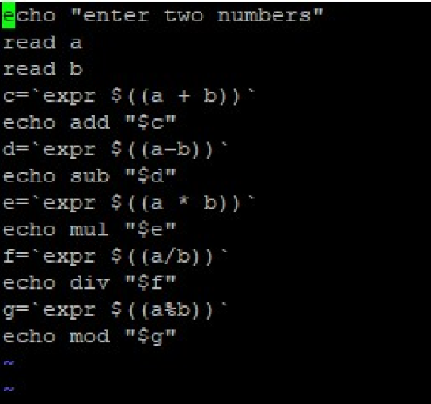

OUTPUT:

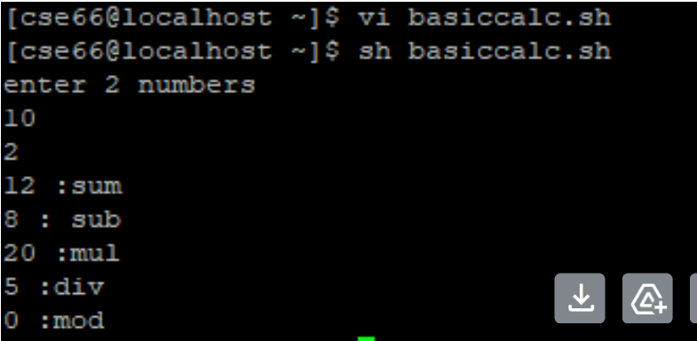

EXP: 2B

PROGRAM:

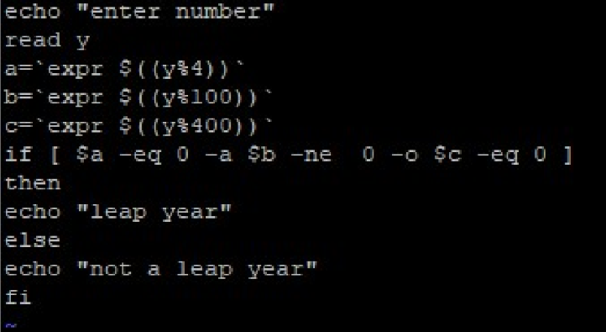

OUTPUT:  
